**Brief Project Walkthrough - DC125222 Lee Cheok Hin**

**Admin Pages**

First, admin need to login to their account.

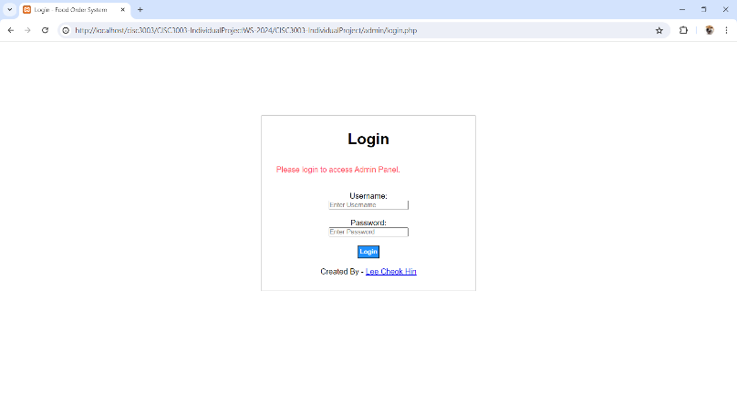

After logging in, they can see the information on the dashboard page

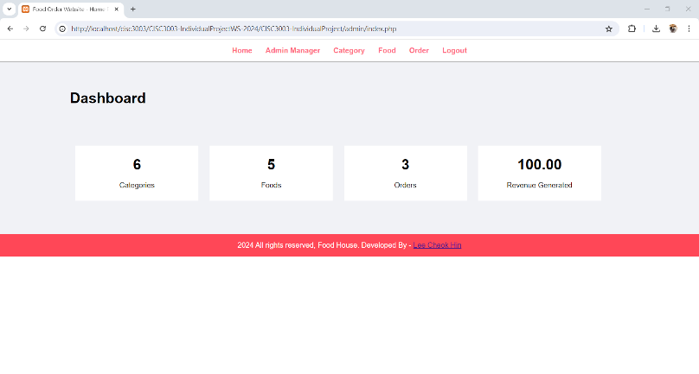

On the **admin manage** page, admins can manage the data of the admin accounts

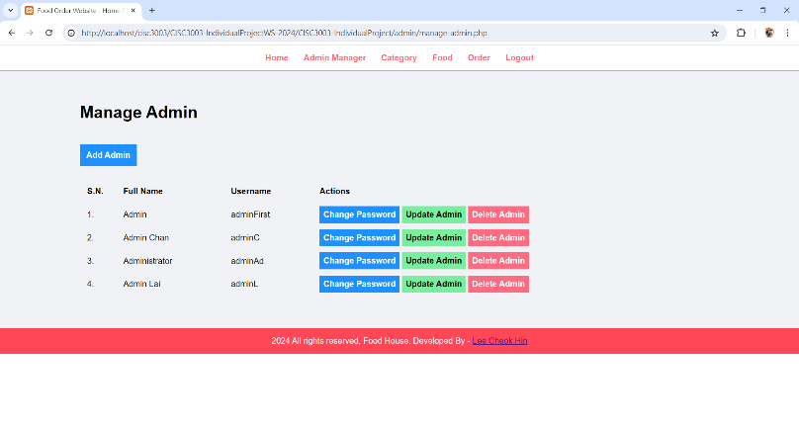

They will be direct to the update page if they click the **update admin** button

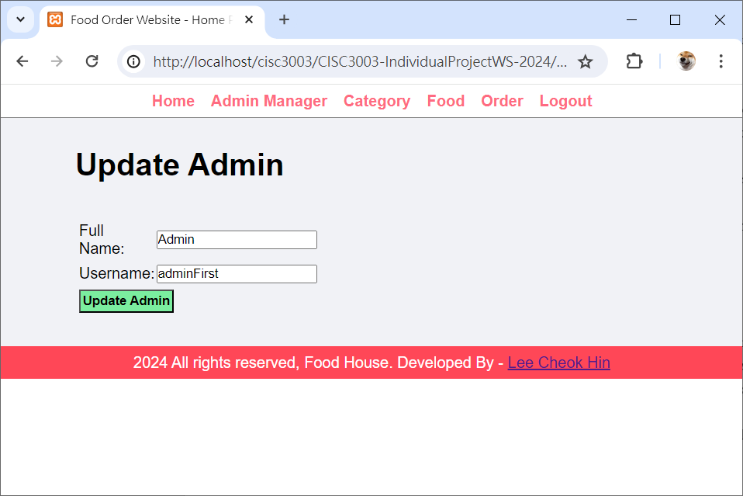

On update page, click the **update admin** button and update information successfully

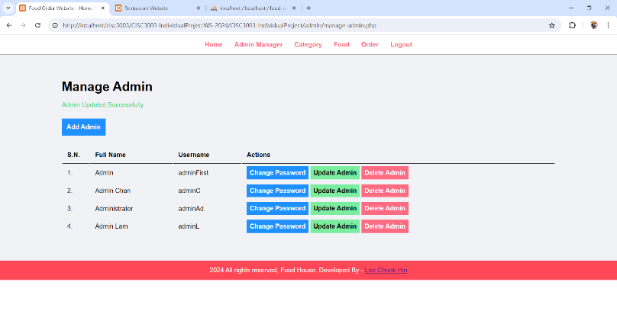

Admins can click the **delete admin** button to delete an admin account

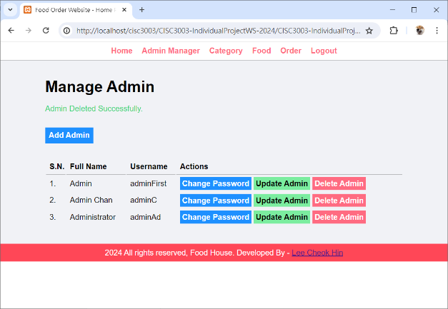

Admins can add admin account by clicking the **add admin** button

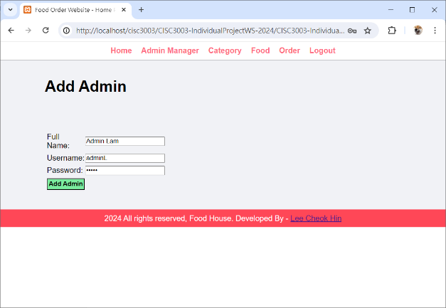

Clicking the **add admin** button to finish the adding

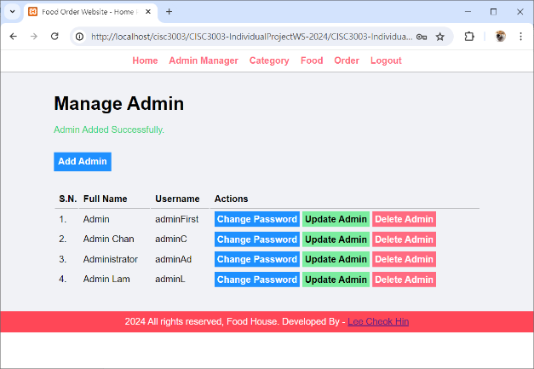

Admins can change the password by clicking the **change password** button

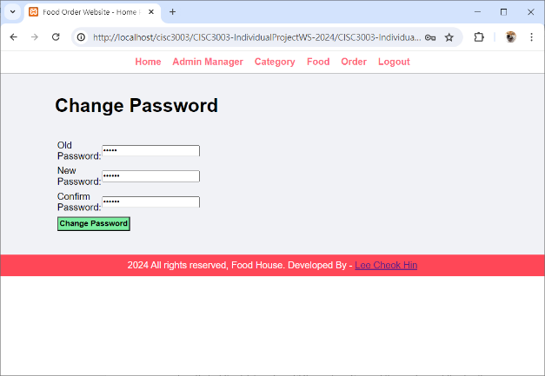

On **category manage** page, admins can see the information of categories in database

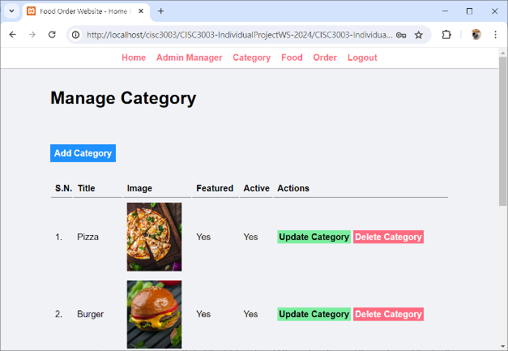

After clicking **update** **category** button, admins can update the data of the categories

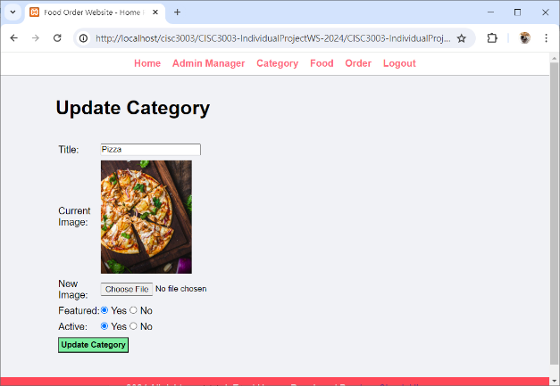

Also, admins can delete the categories by clicking the **delete category** button

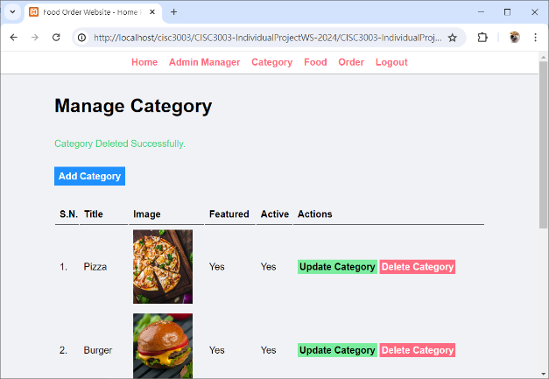

Admins can add a new category by clicking the **add category** button

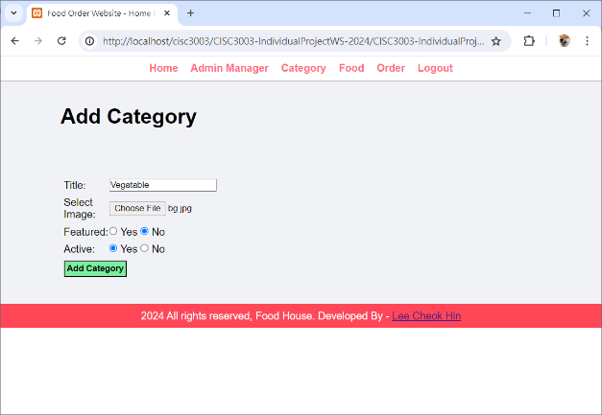

After finishing the form and click the button, a category has been added

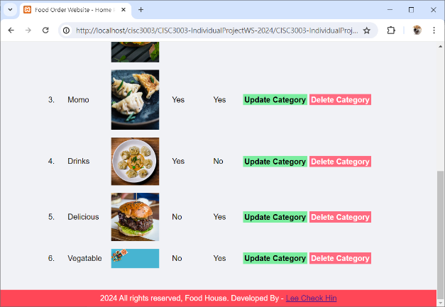

On **food manage** page, admins can manage the foods in database

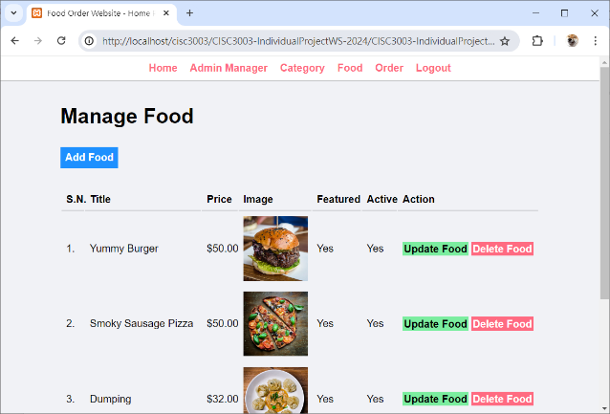

After clicking **update food** button, admins can update the foods data

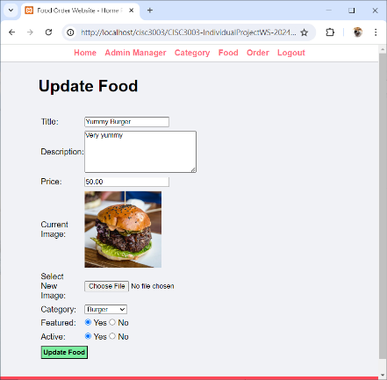

Also, by clicking the **delete food** button, the data of food in database will be deleted, and clicking the add food button admins can add food to the database.

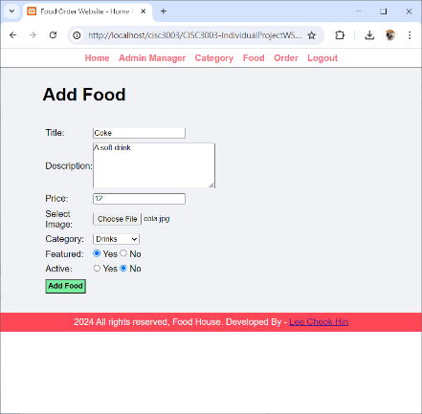

On **manage order** page, admins can manage the order data in the database. However, they cannot add or delete a data on this page

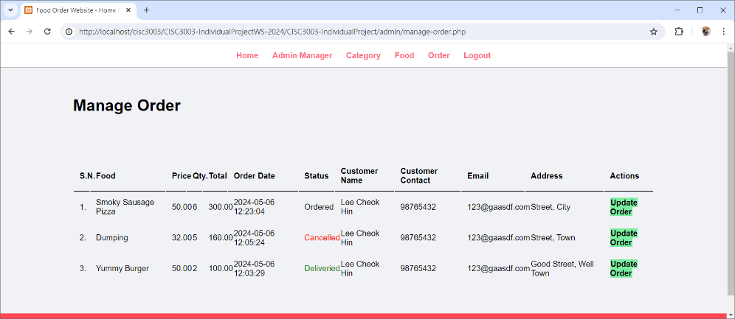

By clicking the **update order** button, admins can update information of the order

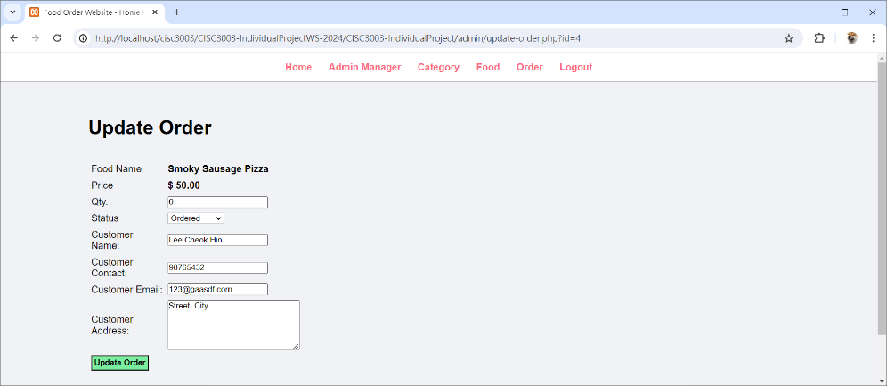

**User Pages**

Users can see the featured categories and foods on the **home** page

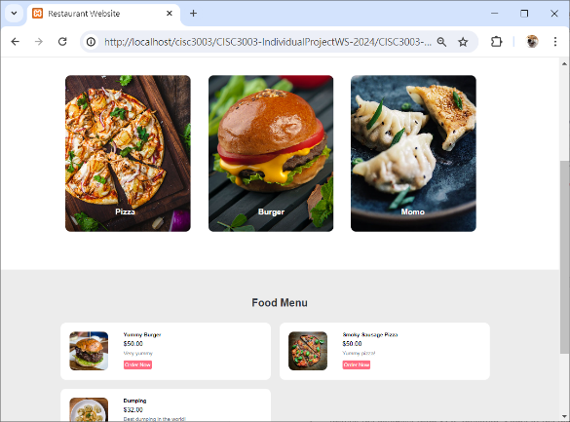

Also, user can find all the categories and foods on **categories** page and **food** page

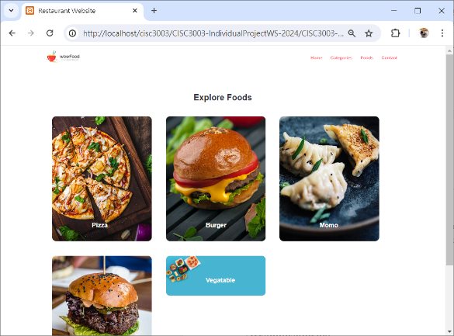 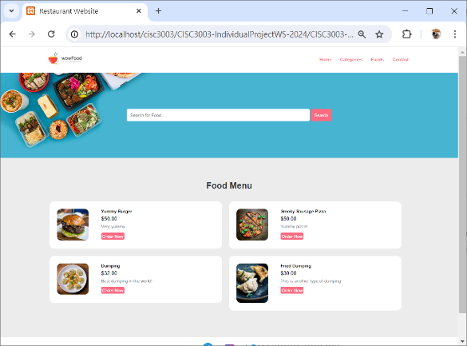

Users can input the keywords to search for the foods they want

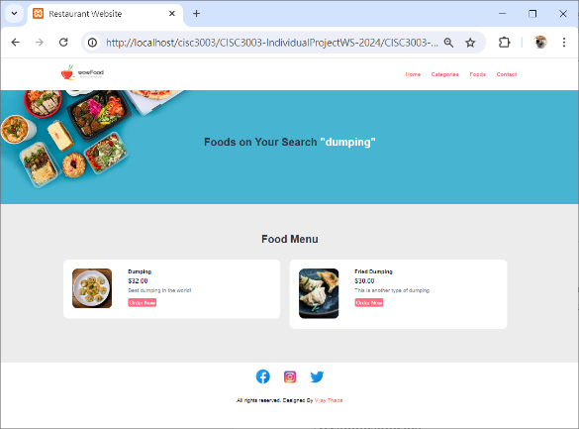

Besides, users can order the food they want

